import numpy

rows = 4

cols = 4

sP = [[0 for _ in range(cols)] for _ in range(rows)]

sP[0][0], sP[0][1], sP[0][2], sP[0][3] = -1.3840, -0.9608, 1.3250, -1.3140

sP[1][0], sP[1][1], sP[1][2], sP[1][3] = 4.5620, 1.3110, -2.3890, 0.2501

sP[2][0], sP[2][1], sP[2][2], sP[2][3] = -0.1280, -1.6280, 1.7020, -0.7620

sP[3][0], sP[3][1], sP[3][2], sP[3][3] = 1, 1, 1, 1

oP = [[0 for _ in range(cols)] for _ in range(rows)]

oP[0][0], oP[0][1], oP[0][2], oP[0][3] = 2, 0, -1, -1

oP[1][0], oP[1][1], oP[1][2], oP[1][3] = 3, 0, -2, 0

oP[2][0], oP[2][1], oP[2][2], oP[2][3] = -3, -3, 2, -2

oP[3][0], oP[3][1], oP[3][2], oP[3][3] = 1, 1, 1, 1

oP_inv = numpy.linalg.inv(oP)

T = numpy.dot(sP, oP_inv)

print(T)

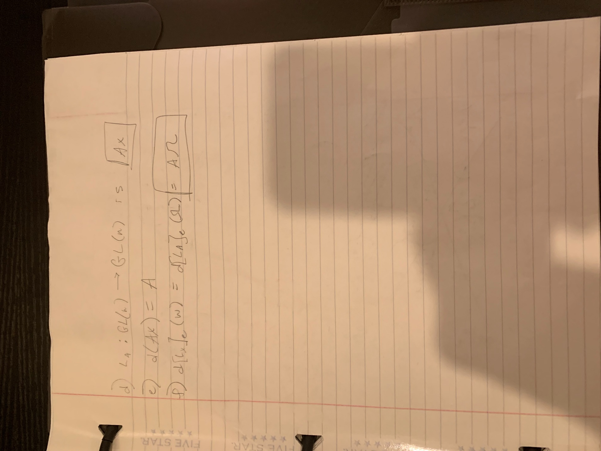

**PART C:**

import numpy

from scipy.linalg import logm, expm

import matplotlib.pyplot as plt

from mpl_toolkits import mplot3d

SE_rows = 4

SE_cols = 4

R_rows = 3

R_cols = 3

t_rows = 3

t_cols = 1

def get_rotation_matrix(X):

rot_mat = [[0 for _ in range(R_cols)] for _ in range(R_rows)]

rot_mat[0][0], rot_mat[0][1], rot_mat[0][2] = X[0][0], X[0][1], X[0][2]

rot_mat[1][0], rot_mat[1][1], rot_mat[1][2] = X[1][0], X[1][1], X[1][2]

rot_mat[2][0], rot_mat[2][1], rot_mat[2][2] = X[2][0], X[2][1], X[2][2]

return rot_mat

def get_position_vector(X):

pos_vec = [[0 for _ in range(t_cols)] for _ in range(t_rows)]

pos_vec[0][0] = X[0][3]

pos_vec[1][0] = X[1][3]

pos_vec[2][0] = X[2][3]

return pos_vec

def homogenize(t, R):

res_mat = [[0 for _ in range(SE_cols)] for _ in range(SE_rows)]

res_mat[0][0], res_mat[0][1], res_mat[0][2], res_mat[0][3] = R[0][0], R[0][1], R[0][2], t[0][0]

res_mat[1][0], res_mat[1][1], res_mat[1][2], res_mat[1][3] = R[1][0], R[1][1], R[1][2], t[1][0]

res_mat[2][0], res_mat[2][1], res_mat[2][2], res_mat[2][3] = R[2][0], R[2][1], R[2][2], t[2][0]

res_mat[3][0], res_mat[3][1], res_mat[3][2], res_mat[3][3] = 0, 0, 0, 1

return res_mat

#return the homogeneous representation after the group multiplication

def group_multiply(X, Y):

X_R = get_rotation_matrix(X)

X_t = get_position_vector(X)

Y_R = get_rotation_matrix(Y)

Y_t = get_position_vector(Y)

return homogenize(numpy.add(numpy.dot(X_R, Y_t), X_t), numpy.dot(X_R, Y_R))

def gamma(t):

X_0 = [[0 for _ in range(SE_cols)] for _ in range(SE_rows)]

X_0[0][0], X_0[0][1], X_0[0][2], X_0[0][3] = 0.4330, 0.1768, 0.8839, 1

X_0[1][0], X_0[1][1], X_0[1][2], X_0[1][3] = 0.2500, 0.9186, -0.3062, 1

X_0[2][0], X_0[2][1], X_0[2][2], X_0[2][3] = -0.8660, 0.3536, 0.3536, 0

X_0[3][0], X_0[3][1], X_0[3][2], X_0[3][3] = 0, 0, 0, 1

X_1 = [[0 for _ in range(SE_cols)] for _ in range(SE_rows)]

X_1[0][0], X_1[0][1], X_1[0][2], X_1[0][3] = 0.7500, -0.0474, 0.6597, 2

X_1[1][0], X_1[1][1], X_1[1][2], X_1[1][3] = 0.4330, 0.7891, -0.4356, 4

X_1[2][0], X_1[2][1], X_1[2][2], X_1[2][3] = -0.5000, 0.6124, 0.6124, 3

X_1[3][0], X_1[3][1], X_1[3][2], X_1[3][3] = 0, 0, 0, 1

X_0_inv = numpy.linalg.inv(X_0)

point = group_multiply(X_0, expm(t*logm(group_multiply(X_0_inv, X_1))))

return point

#plot gamma from start to end inclusive

def plot_gamma(start, end):

xline = []

yline = []

zline = []

for i in range(start, end+1):

xline.append(get_position_vector(gamma(i))[0][0])

yline.append(get_position_vector(gamma(i))[1][0])

zline.append(get_position_vector(gamma(i))[2][0])

fig = plt.figure()

ax = plt.axes(projection='3d')

print(xline,yline,zline)

ax.plot3D(xline, yline, zline)

plt.show()

**PART D:**

import numpy

from scipy.linalg import logm, expm

import matplotlib.pyplot as plt

from mpl_toolkits import mplot3d

SE_rows = 4

SE_cols = 4

R_rows = 3

R_cols = 3

t_rows = 3

t_cols = 1

def get_rotation_matrix(X):

rot_mat = [[0 for _ in range(R_cols)] for _ in range(R_rows)]

rot_mat[0][0], rot_mat[0][1], rot_mat[0][2] = X[0][0], X[0][1], X[0][2]

rot_mat[1][0], rot_mat[1][1], rot_mat[1][2] = X[1][0], X[1][1], X[1][2]

rot_mat[2][0], rot_mat[2][1], rot_mat[2][2] = X[2][0], X[2][1], X[2][2]

return rot_mat

def get_position_vector(X):

pos_vec = [[0 for _ in range(t_cols)] for _ in range(t_rows)]

pos_vec[0][0] = X[0][3]

pos_vec[1][0] = X[1][3]

pos_vec[2][0] = X[2][3]

return pos_vec

def homogenize(t, R):

res_mat = [[0 for _ in range(SE_cols)] for _ in range(SE_rows)]

res_mat[0][0], res_mat[0][1], res_mat[0][2], res_mat[0][3] = R[0][0], R[0][1], R[0][2], t[0][0]

res_mat[1][0], res_mat[1][1], res_mat[1][2], res_mat[1][3] = R[1][0], R[1][1], R[1][2], t[1][0]

res_mat[2][0], res_mat[2][1], res_mat[2][2], res_mat[2][3] = R[2][0], R[2][1], R[2][2], t[2][0]

res_mat[3][0], res_mat[3][1], res_mat[3][2], res_mat[3][3] = 0, 0, 0, 1

return res_mat

#return the homogeneous representation after the group multiplication

def group_multiply(X, Y):

X_R = get_rotation_matrix(X)

X_t = get_position_vector(X)

Y_R = get_rotation_matrix(Y)

Y_t = get_position_vector(Y)

return homogenize(numpy.add(X_t, Y_t), numpy.dot(X_R, Y_R))

def gamma(t):

X_0 = [[0 for _ in range(SE_cols)] for _ in range(SE_rows)]

X_0[0][0], X_0[0][1], X_0[0][2], X_0[0][3] = 0.4330, 0.1768, 0.8839, 1

X_0[1][0], X_0[1][1], X_0[1][2], X_0[1][3] = 0.2500, 0.9186, -0.3062, 1

X_0[2][0], X_0[2][1], X_0[2][2], X_0[2][3] = -0.8660, 0.3536, 0.3536, 0

X_0[3][0], X_0[3][1], X_0[3][2], X_0[3][3] = 0, 0, 0, 1

X_1 = [[0 for _ in range(SE_cols)] for _ in range(SE_rows)]

X_1[0][0], X_1[0][1], X_1[0][2], X_1[0][3] = 0.7500, -0.0474, 0.6597, 2

X_1[1][0], X_1[1][1], X_1[1][2], X_1[1][3] = 0.4330, 0.7891, -0.4356, 4

X_1[2][0], X_1[2][1], X_1[2][2], X_1[2][3] = -0.5000, 0.6124, 0.6124, 3

X_1[3][0], X_1[3][1], X_1[3][2], X_1[3][3] = 0, 0, 0, 1

X_0_inv = numpy.linalg.inv(X_0)

point = group_multiply(X_0, expm(t*logm(group_multiply(X_0_inv, X_1))))

return point

#plot gamma from start to end inclusive

def plot_gamma(start, end):

xline = []

yline = []

zline = []

for i in range(start, end+1):

xline.append(get_position_vector(gamma(i))[0][0])

yline.append(get_position_vector(gamma(i))[1][0])

zline.append(get_position_vector(gamma(i))[2][0])

fig = plt.figure()

ax = plt.axes(projection='3d')

ax.plot3D(xline, yline, zline)

plt.show()

**PART E:**

**

**

**

**

